**Algebra 2**

**5.1-5.4 Review**

**1.** Simplify the following expressions as much as possible. Write your final answer with only positive, rational exponents*.* Note that all variables are *non-negative*.

**a. ** **b. ** **c. **

**2.** Simplify each radical expression. Write your answer in *reduced radical form*. Note: .

**a.**  **b.**  (Note: )

**c.**  **d.** 

**e.**  **f.** 

**3.** A triangle has an area of 8 square feet and a base of  feet. Find the height of the triangle, writing your answer in *reduced radical form*.

**4.** Solve each equation. *Simplify the solution to an integer or a fraction*.

**a.**  **b. ** **c.** 

**5.** Write an equation for , the transformed graph of , if it has been vertically dilated by a scale factor of 2, reflected over the *y*-axis, translated left 6 and up 4.

**6.** Sketch the graph of  and then use the graph to identify the following key features:

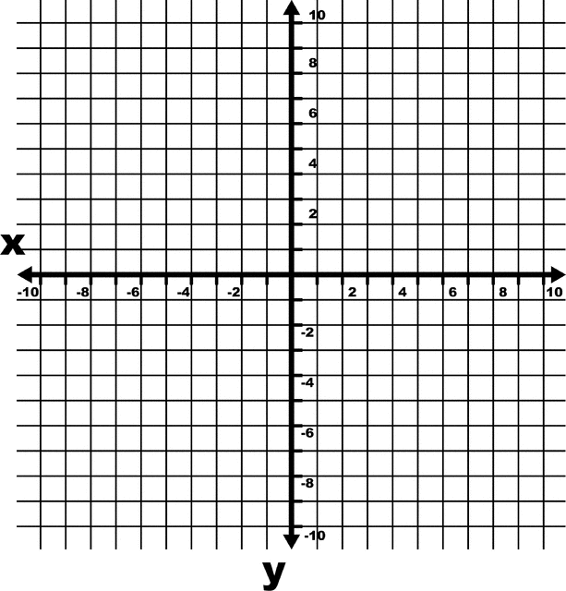**a.** Domain:

**b.** Range:

**c.** Coordinates of thepoint of inflection:

**d.** Interval of *x* where :

**e.** Interval of *x* where  is decreasing:

**f.** Average rate of change of  over the interval :

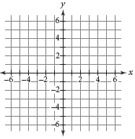

**7.** Sketch the graph of .

**8.** An underground tank in the form of a cylinder must be drained before it can be removed and disposed of. Metal detectors can tell that the tank is 20 feet long, but is unable to ascertain the radius of the cylinder. The tank is known to be half-full and it takes a pump removing the liquid at a rate of  ft3/min 20 minutes to empty the tank.

**a.** Find the volume of the tank.

**b.** Find the radius of the tank.