**Geometry Name ___________________________**

**Probability Review Period ________ Date _____________**

1. A bag of candy contains 12 Snickers, 4 Hershey, 8 Butterfingers and 8 Milky Ways.
2. If you draw a piece of candy from the bag at random, eat it and then draw another piece, what is the probability that you will draw two Butterfingers in a row?
3. If you draw a piece of candy from the bag, and return it, and draw another piece of candy. What is the probability that both are Butterfingers?
4. If you draw four pieces of candy from the bag, and return the piece after each draw, what is the probability that you get a Snickers, Hershey, Butterfinger and Milky Ways in that order?
5. The probability that a randomly selected student at IHS is a junior is 0.27 and the probability that the student is a junior and plays sports is 0.06. The probability that students is neither a junior nor plays sports is 0.43.
6. Create and fill in a Venn Diagram with the given information.
7. What is the probability that the student plays sports?
8. What is the probability that a student is a junior given they play sports?
9. 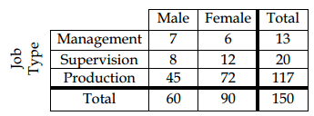For question 3, use the table at the right.
   1. What is the probability that a female is a supervisor?
   2. What is the probability that someone is both a female and a supervisor?
   3. What is the probability that someone is in management?
   4. What is the probability of a randomly chosen person being either a male in production or female in management?
10. Of the 195 students in the senior class, 104 study Spanish and 85 study French, with 12 studying both Spanish and French. What is the probability that a student chosen at random is studying Spanish but not French?
11. Out of 90 people, 32 people like corn, 23 like corn and carrots and 7 like neither. What is the probability that a randomly selected person will like carrots?
12. The table gives the numbers of students in several categories. Use the table to answer the questions.
13. 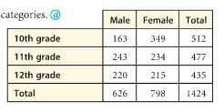What is the probability that a randomly chosen student is a 10th grade female?
14. What is the probability that a randomly chosen 10th grader is a female?
15. What is the probability that a randomly chosen male is a 12th grader?
16. Below is the three day weather forecast for Issaquah,

Day Description High/Low Chance of Precipitation

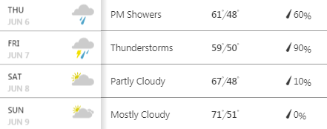

1. What is the probability that it rains exactly 2 days?
2. What is the probability that it doesn’t rain at all?
3. 