**5.5-5.6 Review WS**

1. Let  and let . Perform the indicated operations, then state the domain of the resulting rule.

|  |  |  |
| --- | --- | --- |
| A. | B. | C. |

2. A mapping diagram can be used to represent relations. An arrow is drawn from each input to its output.

A. Fill in the mapping diagram below given that  and  are *inverse relations*.

|  |  |  |  |
| --- | --- | --- | --- |
| *y1*  -8  4  15  173  *x*  1  4  7  1  133 |  | *y2*  4  13  *x*  -8  173 |  |

B. Is *y*1 a function? Is *y*2 a function?

C. If you are given a graph of a function, how can you tell if its inverse will be a function?

3. Algebraically show the pairs of functions below are inverses of each other.

|  |  |
| --- | --- |
| A. ; | B. ; |

4. Find the following below, given ,, , **Write the domain and range of the resulting relations for problems A-D.**

|  |  |
| --- | --- |
| A. | B. |
| C. | D. |
| E. | F. |

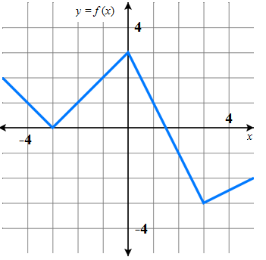5. Use the table, graph, and equations  and  to answer the questions below.

a) 

b) 

c) 

 d) 

e) all  such that 