**2.2 Day 2 – Applications using Point Slope Form Name___________________________**

**Remember….**

Ex 1: Marty is spending money at the average rate of $3 per day. After 14 days he has $68 left. The amount left depends on the number of days that have passed.

**a.** Write an equation for the situation in point slope form.

**b**. Find the amount of money he began with.

**c**. How much money does Marty have after 9 days?

Ex 2: The math department sponsors a Math Family Fun Night each year. In the first year, there were 35 participants. In the third year, there were 57 participants.

**a.** Write an equation to predict how many participants at any given year.

**b.** How many participants are predicted for the 5th year?

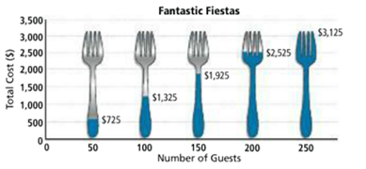Ex 3: An event facility has a banquet hall that can hold up to 250 people. The price for a party includes the cost of the room rental plus the cost of a meal for each guest. Marissa is planning an event for 75 people. She has budgted $1200 for the party. Will it be enough?