3.2 Function Notation Worksheet Name_________________________
- Evaluate the following expressions given the functions below:
a. | b. | c.
d. | e. | f. Find x if
g. Find x if | h. Find x if | i. Find x if

3. Given this graph of the function:
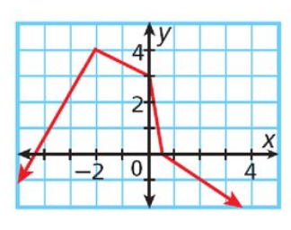
- Write the domain of :

- Write the range of :

Evaluate each of the following:
c. d. e.

f. x, when g. x, when

- Swine flu is attacking Porkopolis. The function below determines how many people have swine where t represents the time in days and S represents the number of people in thousands.

$$S(t)=9t−4$$
- Find S(4).

- What does S(4) mean in the context of the problem?

- Find t when S(t) = 23.

