**TOPIC 2 PRACTICE**  Name\_\_\_\_\_\_\_\_\_\_\_\_\_\_\_\_\_\_\_\_\_\_\_\_\_\_\_\_\_\_

|  |  |  |  |  |  |  |  |  |  |  |  |  |  |
| --- | --- | --- | --- | --- | --- | --- | --- | --- | --- | --- | --- | --- | --- |
| 1. **Write the equation of the line** in slope -intercept form from the given table. Then graph.  a1_cht_c05fr_b_05_SE   |  |  |  |  | | --- | --- | --- | --- | | x | -3 | 2 | 5 | | y | -7 | 8 | 17 | | a1_cht_c05fr_b_05_SE2. Graph *f*(*x*)  3*x* and *g*(*x*)  3*x*  5. Describe the transformation from the graph of *f*(*x*) to the graph of *g*(*x*)?   |  |  |  |  | | --- | --- | --- | --- | |  |  |  |  | |
| 3. Write the equation of the line in slope-intercept form with the slope of -4/7 and y-intercept (0,-8). | 4. Write the equation of the line in slope -intercept form that passes through the points (5, -5) and  (-5, 7). |
| 5. Write the equation of the line in **point slope form** with the slope of 7/2 and contains the point (2,-9). | 6. Which lines are **perpendicular?**  a) 2x + 4y = 10 b) 2x – 4y = 6  c) y – 3 = 1/2(x - 5) d) y = 2x - 5 |
| 7. Which lines are **parallel** out of the 4 lines?  a) 5x + 4y = 16 b) 5x – 4y = 7  c) y – 3 = 5/4(x - 5) d) y = 4/5x + 5 | 8. Write an equation in slope-intercept form that passes through ( 10, -8) and **perpendicular** to the line y = 5/2x – 3. |

1. Write an equation in slope-intercept form that passes through ( 8, -4) and is **parallel** to the line y = 8x + 3.
2. Elmer decided to save the same amount of money each week from his new job. His total savings are shown in the table below.

|  |  |  |  |  |  |  |  |
| --- | --- | --- | --- | --- | --- | --- | --- |
| Weeks at New Job | 0 | 1 | 2 | 3 | 4 | 5 | 6 |
| Total Savings ($) |  |  | 168 |  |  | 240 |  |

What is the slope? What does the slope represent in the situation? (*Show your work).*

What is the y-intercept? What does it represents in this situation?

1. Find the x-intercept algebraically: y-2 = -4(x + 1 )

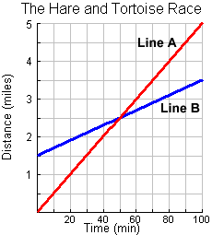

1. The Hare and the Tortoise were racing. The Tortoise was given a head start yet cannot run as fast as the Hare. The graph to the right shows the distances each can travel if they run at their typical speeds. (2 pts)

* What are the slopes of each line?
* What do these slopes mean in this situation?
* Write an equation for each line in slope-intercept form.

1. What is the slope of the line perpendicular to the line? (*Circle your choice.*)

a.  c. 

b. d. 

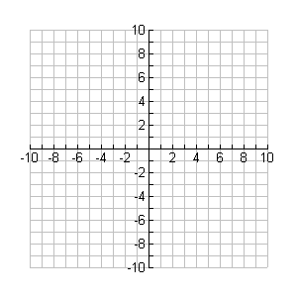

1. Graph the line  on the grid provided.
2. Write the equation of the line through (5,2) and has the slope -3/5 three ways.

Point-slope Slope-intercept Standard form

1. Rewrite the equation  in slope intercept form.

1. Rewrite the equation 2*x* + 3*y* = 12 in slope intercept form.
2. Write an equation of the line in slope-intercept form through the points (12, 35) and (20, 55). (*Show your work*.)
3. Sherlock Holmes charges his clients to solve a case according to the rule,  where *d* is the number of days for him to solve the case and *C* is the total charge in dollars. What does the ordered pair (23, 61) represent in the given situation?
4. Brad needs to earn $600 for a mountain bike that he wants. He is depositing money into his savings account while working two different jobs this summer. For each lawn mowed he deposits $25 and for each landscaping job he puts in $50.
5. Write an equation in standard form to represent the situation. Be sure to define your variables.
6. Find the x- intercept and explain what the intercept represents in the context of the situation.
7. Find the y-intercept and explain what the intercept represents in the context of the situation.

