Topic 3 Test Review Warm Up Name___________________

**1.** Complete each cell in the table. Each row will include a sequence of the first 5 terms and a corresponding recursive and explicit formula.

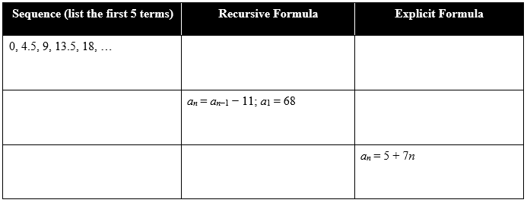







Topic 3 Test Review Warm Up Name___________________

**1.** Complete each cell in the table. Each row will include a sequence of the first 5 terms and a corresponding recursive and explicit formula.









**2.** Jenny and Jonny sell seashells by the seashore. Each seashell is sold for $6. The collected 40 seashells to sell. They **paid** $35 for supplies to start their business.

**a.** Write a function for Jenny and Jonny’s profits.

**b.** Write a domain for the function.

**c.** Write a range for the function.

**d.** If Jenny and Jonny sell 14 seashells, how much profit do they earn?

**2.** Jenny and Jonny sell seashells by the seashore. Each seashell is sold for $6. The collected 40 seashells to sell. They **paid** $35 for supplies to start their business.

**a.** Write a function for Jenny and Jonny’s profits.

**b.** Write a domain for the function.

**c.** Write a range for the function.

**d.** If Jenny and Jonny sell 14 seashells, how much profit do they earn?