**2.3 – 2.4 Quiz Review Name: __________________________**

1. Use the following equation to answer the questions below: 
2. 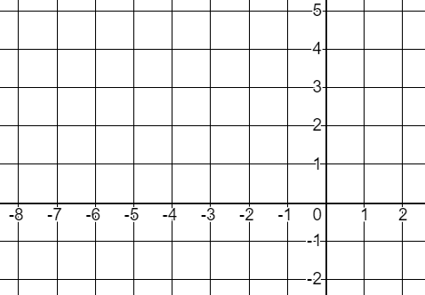What form of linear equation is this?
3. Calculate the x – intercept
4. Calculate the y – intercept
5. Graph the line on the coordinate plane
6. Convert the equation to slope – intercept form
7. Use the following equation to answer the questions below: 
8. 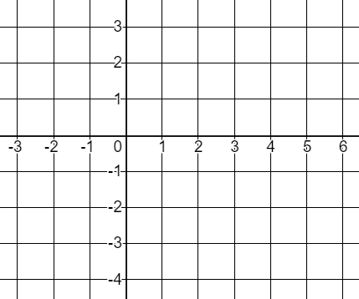What form of linear equation is this?
9. Calculate the x – intercept
10. Calculate the y – intercept
11. Graph the line on the coordinate plane
12. Convert the equation to slope – intercept form
13. Jeremy is purchasing tea and coffee for a weekend retreat. Each box of tea cost $3.50 and each bag of coffee cost $8.75. Jeremy has a budget of $70 for refreshments.
14. Write an equation in standard form to model the scenario. Let represent boxes of tea and represent bags of coffee
15. What is the maximum number of boxes of tea that Jeremy could purchase?
16. What is the maximum number of bags of coffee Jeremy could purchase?
17. If Jeremy purchases 5 bags of coffee, how many boxes of tea will he purchase?
18. Genevieve has $90 to spend on ping-pong paddles and ping-pong balls for her after-school club. Paddles cost $6 and a set of pin-pong balls cost $5.
19. Write an equation in standard form to model the scenario. Let represent the number of paddles and represent the number of balls

1. What is the maximum number of paddles Genevieve could purchase?
2. What is the maximum number of ball sets Genevieve could purchase?
3. If Genevieve purchases 10 paddles, how many sets of ping-pong balls can she purchase?
4. Convert the following equations from standard form to slope – intercept form
5.  b) 
6. Write the equation of a line that passes through the 7) Write the equation of a line that passes through the

point  and is parallel to the line  point and is perpendicular to the line 

8) Write the equation of a line that is vertical and passes 9) Write an equation of a line that is horizontal and passes

through the point  through the point 