3.2 Function Notation Notes Name___________________________

Review:

**Ex1.** Given  calculate each of the following:

**a.  b.  c. ** when 

Evaluating Functions from a Graph

**Ex 2:** Below is a graph of the function 

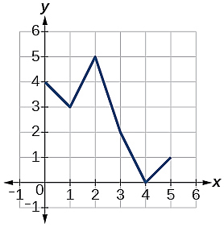

a. Find 

b. Find 

c. x when 

d. x when 

**Ex 3:** Below is a graph of the function 

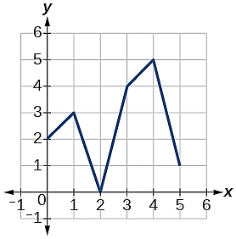

a. Find 

b. Find 

c. x when 

d. x when 