1.1 Measuring Segments and Angles
Description |  | Diagram | Notation
Point: a location but no size (undefined)

Line: an infinite number of points on a straight path that extends in two opposite directions with no end; has no thickness (undefined)
Plane: an infinite number of points and lines on a flat surface that extends without end and has no thickness (undefined)
Segment: a part of a line that consists of _________________

_______________________________________________________________.
Ray: the part of a line that consists of ____________________

_______________________________________________________________.
Opposite Rays: rays with the same ________________________

_______________________________________________________________.
Angle: formed by two rays with the _______________________

_______________________________________________________________.
Congruent: a relationship between two geometric figures where their measures are the same.
Example 1: How can you find the length of $\overline{CD}$? Show your work or describe your thinking.
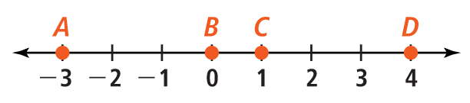

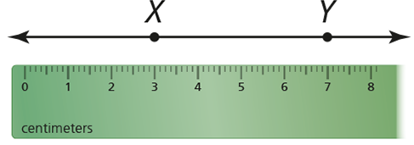
Ruler Postulate: Every point on a line can be paired with a unique real number, the coordinate of the point.

Coordinate of X: ________

Coordinate of Y: ________
Distance on a Line: found by taking the absolute value of the difference of the points’ coordinates.

Example 2: Find KL.
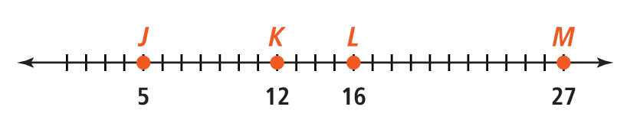

Segment Addition Postulate: If points A, B, and C are on the same line, with B between A and C, then
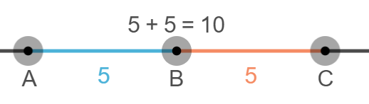
$AB+BC=AC$.

Example 3: Points F, G, and H are collinear. If $GH=16$, what is FH?
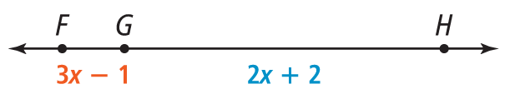

Protractor Postulate:
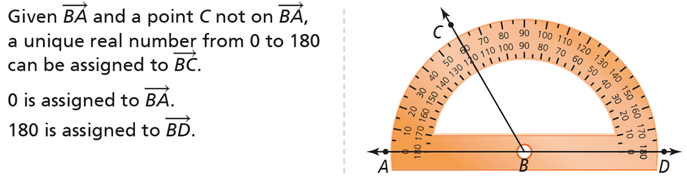

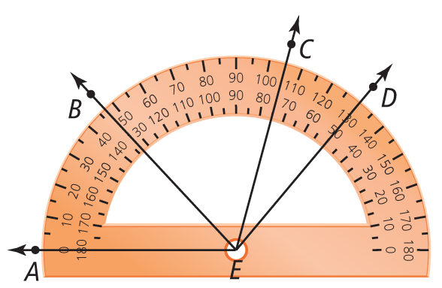
Example 4: Read the protractor to the right. What is $m∠BEC$? Show work to support your answer.

Angle Addition Postulate: Using the protractor above, $m∠AEB+m∠BEC=m∠AEC$.

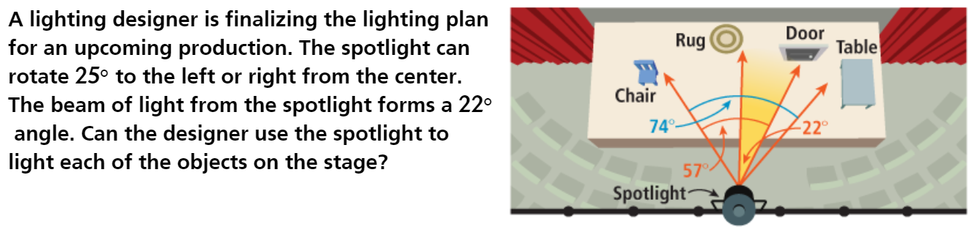
Example 5:

1.2 Basic Constructions
Construction: A geometric figure made using only ____________________________________________________________.
Straightedge: used to make segments, lines, and rays.
Compass: used to make circles and arcs. Also used to measure and copy length.
Copying a Segment
1. Draw a ray that is a little longer than the segment you are copying.  2. Open your compass to the length of the original segment, then transfer to the ray you drew. Use an arc to mark the distance. |  | A  B
Copying an Angle
1. Draw a ray. This will become one of the sides of the angle you are copying.  2. On the original angle, anchor at the vertex and make an arc that goes across both sides.  3. Without changing the compass opening, transfer the same arc to the ray you drew.  4. On the original angle, use your compass to measure the distance of the arc from the intersection points on both sides of the angle. |  | 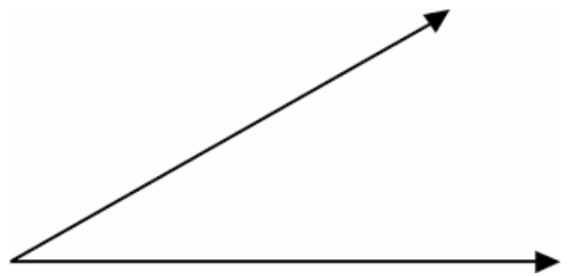
Perpendicular: Intersecting to form ____________________________________________________________________________.
Bisector: A line, segment, or ray that splits a geometric figure into __________________________________________.
Constructing a Perpendicular Bisector
1. Open your compass to more than half of the length of the segment you are bisecting.  2. From each endpoint, make an arc on both sides of the segment. The arcs should intersect.  3. Connect the two intersection points together. This segment is the perpendicular bisector. |  | A  B
Constructing an Angle Bisector
1. Anchor at the vertex of the angle. From there, make an arc that crosses both sides of the angle.  2. Locate the intersection points formed by the arc and the two sides.  3. Anchor from each intersection point mentioned above, and arc towards the middle of the angle. The arcs should intersect.  4. Connect the vertex and the intersection point from above to locate the angle bisector. | 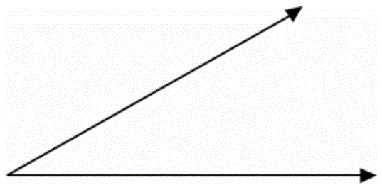
Additional Examples
Copy $\overline{EF}$ in the space below.  E  F | Copy the angle in the space below.  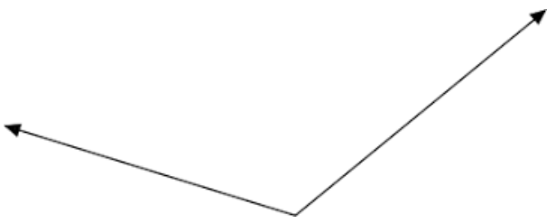
Construct the perpendicular bisector of $\overline{CD}$,$\overset{⃡}{ AB}$, in the space below.  C  D | 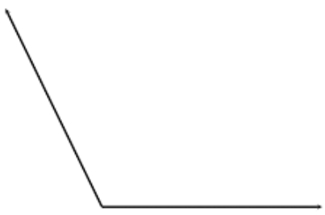  Construct the angle bisector of the angle below.

1.3 Midpoint and Distance
Warm up!
LaTanya is decorating her new apartment. She draws a sketch of the floor plan to look at placement.
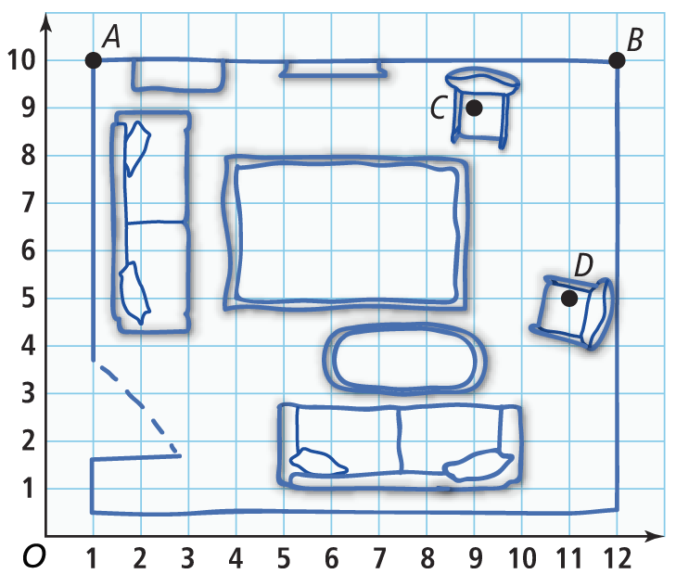
A. She wants to hang a picture on the center of the wall $\overline{AB}$. About what point should she center the picture?

B. She wants to place a floor lamp halfway between chairs C and D. About what point should she center the floor lamp? Show work or explain your thinking.

Midpoint:

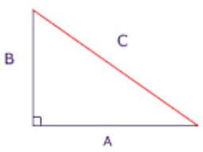
Pythagorean Theorem (review):

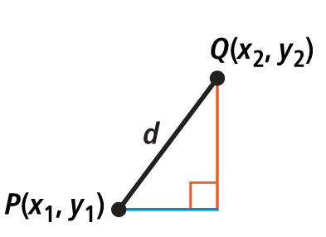
Using Pythagorean Theorem to Derive the Distance Formula

Midpoint Formula | Distance Formula
Example 1
Find the midpoint of $\overline{AB}$.
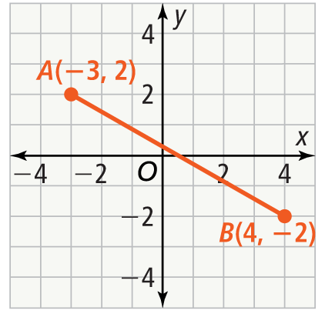

Example 2
Find the point that is$\frac{3}{5}$of the way from A to B.
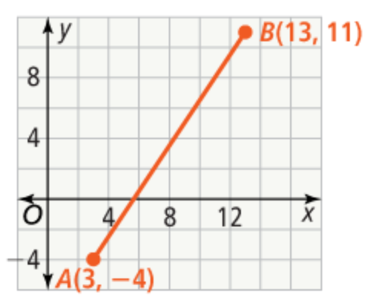
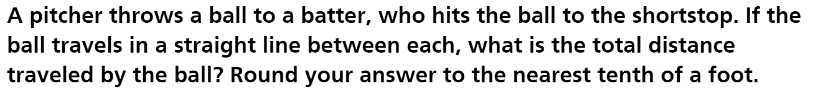
Example 3

