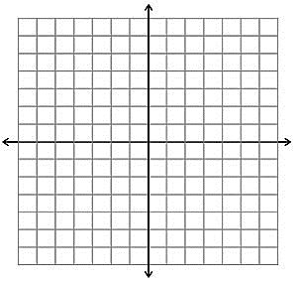**Climb the Ladder** –

2.1 – Slope Intercept Form

**1.** Graph 

**a.** State the slope:

**b.** State the y intercept:

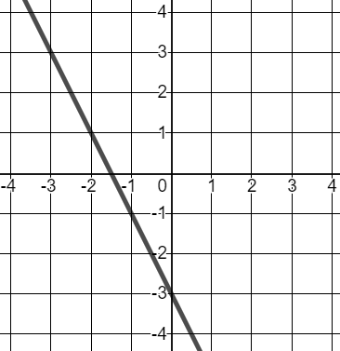**2.** Write an equation in slope intercept form for the graph below.

**Climb the Ladder**

* 1. – Slope Intercept Form

**1.** Graph 

**a.** State the slope:

**b.** State the y intercept:

**2.** Write an equation in slope intercept form for the graph below.



**1**

**1**

**Climb the Ladder**

* 1. – Point Slope Form

**1.** Write the point-slope equation of a line with a slope of 3, which passes through the point (4, 12)

**2**

**2.** Martha is collecting marbles. After 4 days, she has 14 marbles and after 10 days she has 74 marbles.

**a.** Write and equation in point slope form that represents this scenario.

**b.** How many marbles will she have after 15 days?

**Climb the Ladder**

2.2 – Point Slope Form

**1.** Write the point-slope equation of a line with a slope of 3, which passes through the point (4, 12)

**2**

**2.** Martha is collecting marbles. After 4 days, she has 1410* marbles and after 10 days she has 74 marbles.

**a.** Write and equation in point slope form that represents this scenario.

**b.** How many marbles will she have after 15 days?

**Climb the Ladder** –

* 1. – Standard Form

**1.** Algebraically find the x and y intercepts of the equation 

**3**

**2.** Jamie is planning a dinner party. Pasta costs $15 per person, and steak costs $18 per person. She has a budget of $225 to spend on the dinner party.

**a.** Write an equation that represents Jamie’s situation.

**b.** If five people request steak, how many people will get pasta?

**Climb the Ladder**

* 1. – Standard Form

**1.** Algebraically find the x and y intercepts of the equation 

**3**

**3**

**2.** Jamie is planning a dinner party. Pasta costs $15 per person, and steak costs $18 per person. She has a budget of $225 to spend on the dinner party.

**a.** Write an equation that represents Jamie’s situation.

**b.** If five people request steak, how many people will get pasta?

**Climb the Ladder** –

2.4 - Parallel Lines & Perpendicular Lines

**1.** Write the equation of a line parallel to , that passes through the point (7, 8)

**4**

1. One line passes through the points (12, 5) and (2, 20). Write the equation of a perpendicular line with a y-intercept of -2

**Climb the Ladder**

* 1.  - Parallel Lines & Perpendicular Lines

**1.** Write the equation of a line parallel to , that passes through the point (7, 8)

**4**

1. One line passes through the points (12, 5) and (2, 20). Write the equation of a perpendicular line with a y-intercept of -2

**Climb the Ladder**

**1.** Rufus has 3 soda cans to recycle. In order to help save the planet, he plans to collect an additional 5 cans each week.

**5**

**a.** What is the slope? What does it mean in the context of the problem?

**b.** What is the y-intercept? what does it mean in the context of the problem.



**c.** Write an equation that models this scenario in slope intercept form.

**d.** Graph your equation. Make sure to scale and label your axis!!

**e.** After how many weeks will Rufus have collected 103 cans?

**f.** How many cans will Rufus have after 6 weeks?