**Geometry 12.2 Worksheet Name ___________________________**

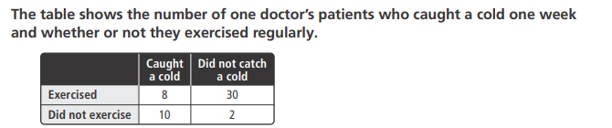

1. Find
2. Find
3. Are the events “did not exercise” and “did not catch a cold” dependent or independent events? Explain.

Consider the following table giving the contestants in a dog race.

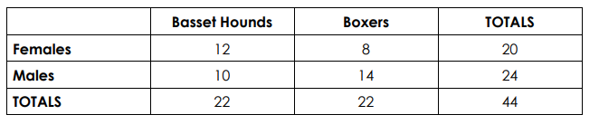

1. Find 5.

7.

The table show the number of students on different teams by grade. One of these students is selected at random for an interview.

|  |  |  |
| --- | --- | --- |
|  | Sophomore | Junior |
| Cross Country | 9 | 6 |
| Track | 12 | 23 |

1. Find 9.

11.

1. Ms. Grossman draws a card to call on a student to answer a question. There are 30 cards in her deck for the 30 seats in the classroom.
2. If she draws two cards at random and doesn’t return the card to the deck, what is the probability that she chooses a member from your group each time? (assume a group of 4)
3. If she draws two cards at random and does return the card to the deck, what is the probability that she chooses a member from your group each time? (assume a group of 4)
4. A survey was taken of IHS students about their summer plans. Students were asked to check a box for the following activities: traveling, working, or other. They were allowed to check multiple boxes. The following data was collected:

40% are traveling. 12% are neither traveling nor working. 23% are working and traveling

a. Create a Venn Diagram for this situation. b. Find the value of each probability indicated:

i. P(not T)

ii. P (T or W)

iii. P(W|T)

1. A bag contains red, green, blue, yellow and white counters.

The table below shows the probabilities of obtaining each colour when a counter is taken at random from the bag.

|  |  |  |  |  |
| --- | --- | --- | --- | --- |
| Red | Green | Blue | Yellow | White |
| 0.3 | 0.25 | 0.2 | 0.2 | 0.1 |

1. How can you tell that there is a mistake in the table?
2. The probability of getting a white counter is wrong. What should it be?

1. A counter is taken at random from the bag.
2. What is P(Green or Blue)?
3. What is P(Red or Green or Blue)?
4. What is P(not Yellow)?