**6.1: Polygon Angle – Sum Theorem**

1. Find the sum of the interior angles of the following polygons.

a) dodecagon b) 20-gon

2. How many sides does a regular polygon have if the measure of one interior angle is ?

3. What is the measure of an interior angle of a regular 24-gon?

4. How many sides does a regular polygon have given the measure of an exterior angle is ?

5. What is the sum of the measures of the exterior angles of 18-gon?

6. What is the measure of each angle? 7. What is the value of x?

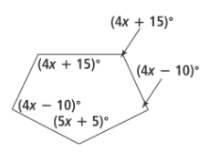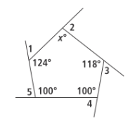











**6.2: Kites and Trapezoids**

8. *ABCD* is a kite. Find the missing lengths and angle measures.

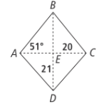 *AC =*

*CD =*





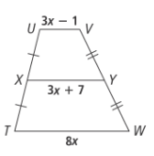9. What is the length of *XY*?

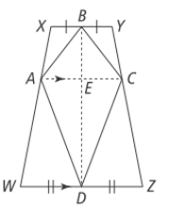

10. **Given**: *ABCD* is a kite and *WXYZ* is an isosceles trapezoid

**Prove:** 

|  |  |
| --- | --- |
| **Statement** | **Reason** |
| and |  |
|  |  |
| and |  |
|  |  |
|  | HL Theorem |
|  |  |
|  | Alternate Interior Angles Thm |
|  | Transitive Property of Equality |
|  |  |

**6.3: Properties of Parallelograms**

11. Find the perimeter of the parallelogram. 12. Find the missing angle measures.

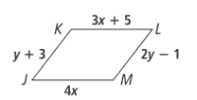 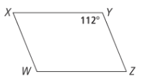

13. Find the stated side lengths.

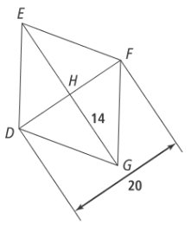*EG =*

*DH =*

**6.4: Proving a Quadrilateral is a Parallelogram**

14. Is there enough information to prove each quadrilateral is a parallelogram? Explain.

a) b)

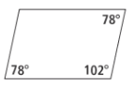 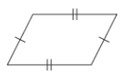

15. For what values of *a* and *b* is each quadrilateral a parallelogram?

a) b)

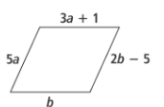 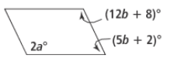

**6.5: Properties of Special Parallelograms**

16. Find the stated lengths and angle measures for 17. Find the stated lengths and angle measures for

rhombus *ABCD.* rectangle *LMNO.*

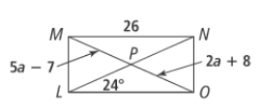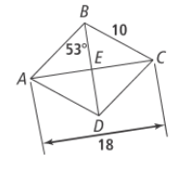 *AB =*

*DE=*





*MO =*

*LM =*

*LP =*



**6.6: Conditions of Special Parallelograms**

18. Which word best describes the parallelogram: parallelogram, rectangle, rhombus or square?

a) b)

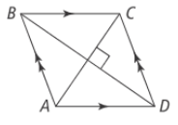 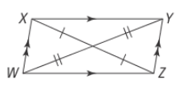

c) d)

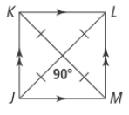 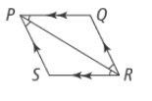

19. What values of x makes the description of each parallelogram true?

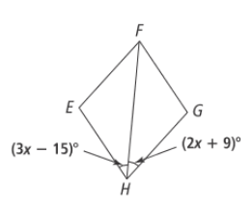a)  is a rectangle, and b) is a rhombus



