**Algebra 1 8.1 8.2 Notes Name ________________________________**

**Warm-up:**

Graph the absolute value function.

1. 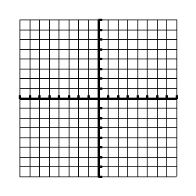 2) 

________________________________________________________________________________________________

**Parent Function of Quadratic:**

|  |  |
| --- | --- |
| **x** | **Y** |
| -3 |  |
| -2 |  |
| -1 |  |
| 0 |  |
| 1 |  |
| 2 |  |
| 3 |  |

Domain: Range: Vertex:

Axis of Symmetry:

**Transformed Quadratic Function:** 

**a: x + h:**

**-a: x – h:**

**+ k :**

**-k:**

**Sketch each parabola. Then state the vertex, axis of symmetry, domain and range.**

1.  2) 

Domain: Range: Domain: Range:

Vertex: Axis of Symmetry: Vertex: AOS:

3)  4) 

Domain: Range: Domain: Range:

Vertex: AOS: Vertex: AOS:

**Write the equations of the parabolas.**

