Name: _________________________________________________ Period: _______ Date: _________

**3.3 Day 2 Entry Task – Translations, Reflections, and Rotations**

**Write the rule for the transformation given and graph the image of the figure.**

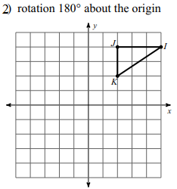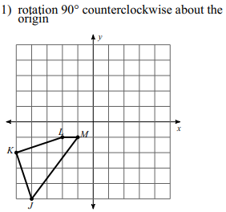

Rule: ________________ Rule: ________________

3) What type of transformation was done to A(-5, 2) to get A’(2, 5)?

Name: _________________________________________________ Period: _______ Date: _________

**3.3 Day 2 Entry Task – Translations, Reflections, and Rotations**

**Write the rule for the transformation given and graph the image of the figure.**



Rule: ________________ Rule: ________________

3) What type of transformation was done to A(-5, 2) to get A’(2, 5)?

4) Write a rule for the composition of transformations that yielded E’’F’’G’’.

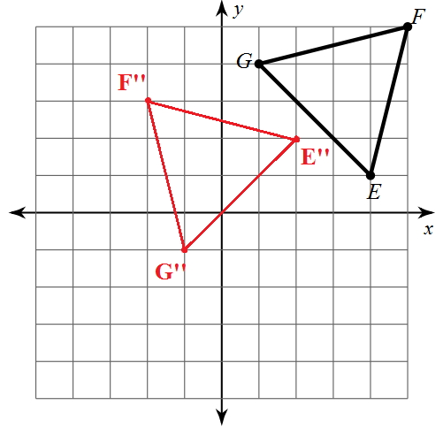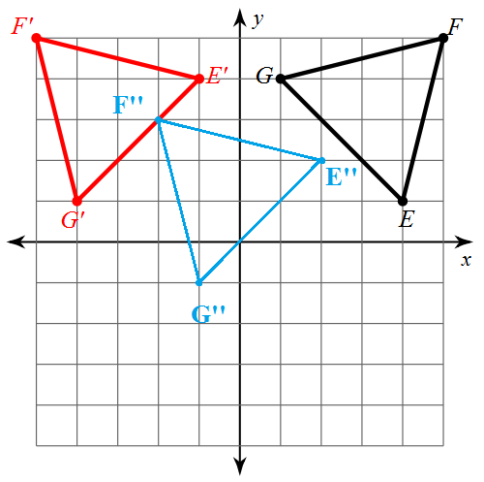

4) Write a rule for the composition of transformations that yielded E’’F’’G’’.

