**TOPIC 2 QUEST REVIEW** Name_________________________ Per._______

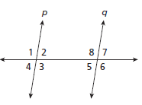

1. Use the diagram to the right to determine if the lines are parallel **in each** situation. If they are parallel show and state how you know. **State your reason for each problem**.
2.  b. , ,  c. 
3. **Use slope** to determine whether the lines are parallel, perpendicular, or neither. Show your work.
4. and for *A*(4, 7) , *B*(3, 2), *C*(-3, 4), *D*(2, 3)
5. and for *E*(-2, 4), *F*(3, 1), *G*(-1, -2), *H*(4, -5)
6. Write an equation of a line in *slope-intercept form* that is parallel to  and passes through.
7. Write an equation of a line in *point-slope form* that is perpendicular to  that passes through .
8. Solve for *x*. **State your reason for your equation**, and show all work when solving for *x*.

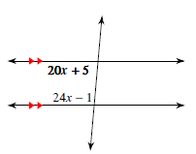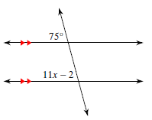a. b.

c. 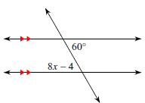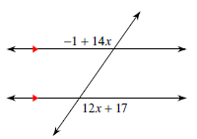 d.

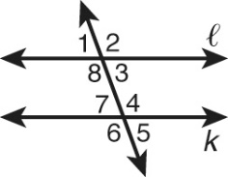4. Complete the proof.

Given: k || 

Prove: 1 and 6 are supplementary.

Proof:

|  |  |
| --- | --- |
| **Statements** | **Reasons** |
| 1. k || | 1. Given |
| 2. m1  m5 | 2. |
| 3. m5  m6  180° | 3. |
| 4. m1  m6  180° | 4. |
| 5. 1 and 6 are supplementary. | 5. |

For problems 5-9 , solve for the missing variable(s) in each diagram.

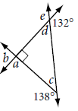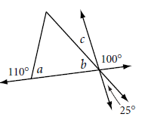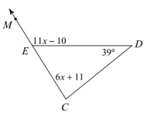5. 6. 7.

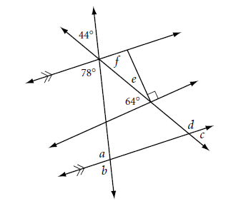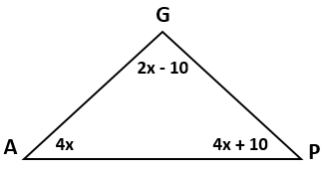8. 9.

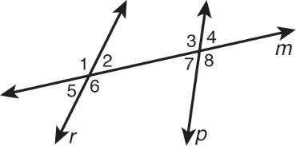

10. **Use the diagram to the right**. Place a checkmark for the correct term to describe the given angle pair’s relationship.

|  |  |  |  |  |  |  |
| --- | --- | --- | --- | --- | --- | --- |
|  | **∠4 and ∠3** | **∠2 and ∠7** | **∠7 and ∠6** | **∠2 and ∠5** | **∠1 and ∠8** | **∠2 and ∠4** |
| Corresponding Angles |  |  |  |  |  |  |
| Alternate Interior Angles |  |  |  |  |  |  |
| Alternate Exterior Angles |  |  |  |  |  |  |
| Same Side Interior Angles |  |  |  |  |  |  |
| Vertical Angles |  |  |  |  |  |  |
| Linear Pair |  |  |  |  |  |  |