**PARALLEL AND PERPENDICULAR LINES NAME_____________**

**Match up the slopes that are parallel or perpendicular.**

|  |  |
| --- | --- |
| **m = 3 m = -3 m = ¼**  **m = -1/4 m = 3 m = -5**  **m = 4 m = 5/2 m = 2/3**  **m = 1/3 m = -5 m = -5/2**  **m = ¼ m = -3/2 m = 5/2** | **Slopes // or**  **1.**  **2.**  **3.**  **4.**  **5.**  **6.**  **7.** |

**Match up the equations that are parallel or perpendicular.**

**Then identify if // or**  **or neither.**

**a) y = 5x +2 e) y = 5/4x +8**

**b) y = -2x -5 f) y = 3/8 x - 9**

**c) y = 3/8x + 10 g) y = -5x +2**

**d) y = -4/5x -7 h) y = 1/2x - 5**

**i) y = -8x – 10 j) y = -8x – 10**

**k) y = -5x +7 l) y = -6x + 2**

**Which sets of lines look // or**  **or neither? What can you do to prove it? Do it. Now which are // or**  **or neither?**

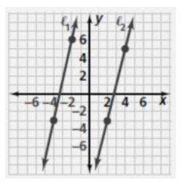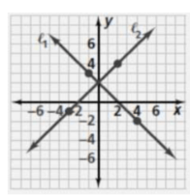a) b)

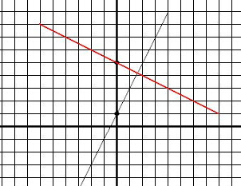

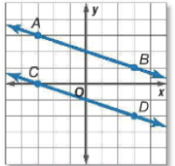c) d)

**Write the equation on the line that is parallel to y= 1/2x + 3 that passes through the point (-6, 5).**

**Write the equation of the line that is perpendicular to y = 2/5x – 6 that passes through the point (- 10, -10).**

**Write the equation on the line that is parallel to y= -3/2x - 8 that passes through the point (-6, 11).**

**Write the equation of the line that is perpendicular to y = -3/5x + 4 that passes through the point (- 15, 16).**