Quadratic Sort
Match each equation of a quadratic with a graph and a description of the transformation. Glue in groups of three onto a sheet of notebook paper.
A  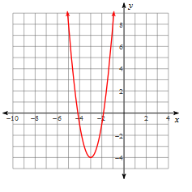 | I  $$y=-2{\left(x+3\right)}^{2}+4$$ | Q  Reflected over the x-axis, vertical dilation of 2 and translated left 3 and up 4.
B  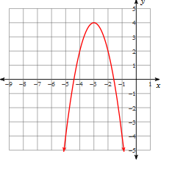 | J  $$y=2{\left(x-1\right)}^{2}-1$$ | R  Reflected over the x-axis and translated right 2 and down 4
C  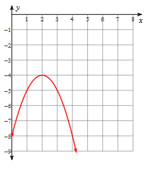 | K  $$y=-5{\left(x-1\right)}^{2}+1$$ | S  Reflected over the x-axis, vertical dilation of 5 and translated right 1 and up 1.
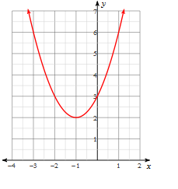  D | L  $$y={\left(\frac{x-1}{2}\right)}^{2}$$ | T  Horizontal dilation of 2 and translated right 1
E  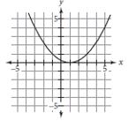 | M  $$y={\left(\frac{x-4}{2}\right)}^{2}+2$$ | U  Vertical dilation of 2 and translated right 1 and down 1
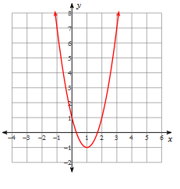  F | N  $$y=3{\left(x+3\right)}^{2}-4$$ | V  Horizontal dilation of 2 and translated right 4 and up 2.
G  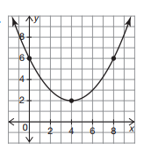 | O  $$y=-{\left(x-2\right)}^{2}-4$$ | W  Vertical dilation of 3 and translated left 3 and down 4.
H  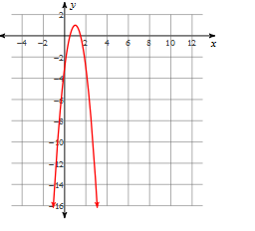 | P  $$y={\left(x+1\right)}^{2}+2$$ | X  Translated left 1 and up 2.

