2.1-2.2 Review Worksheet Name_________________________

Algebra 1

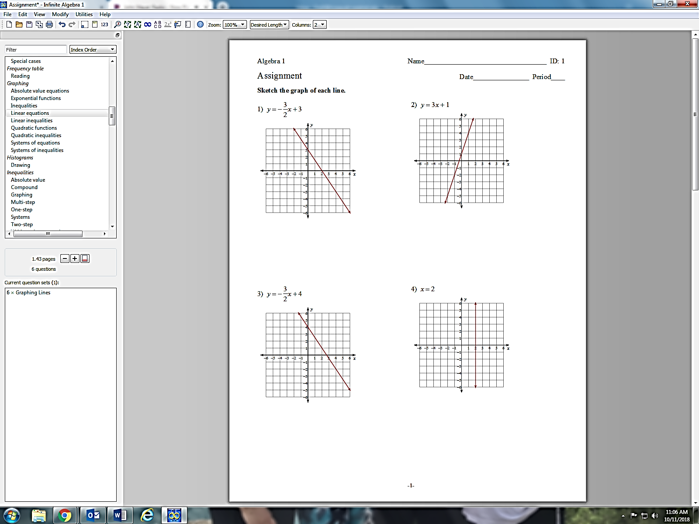**1) Write an equation for each graph in *slope intercept form.***



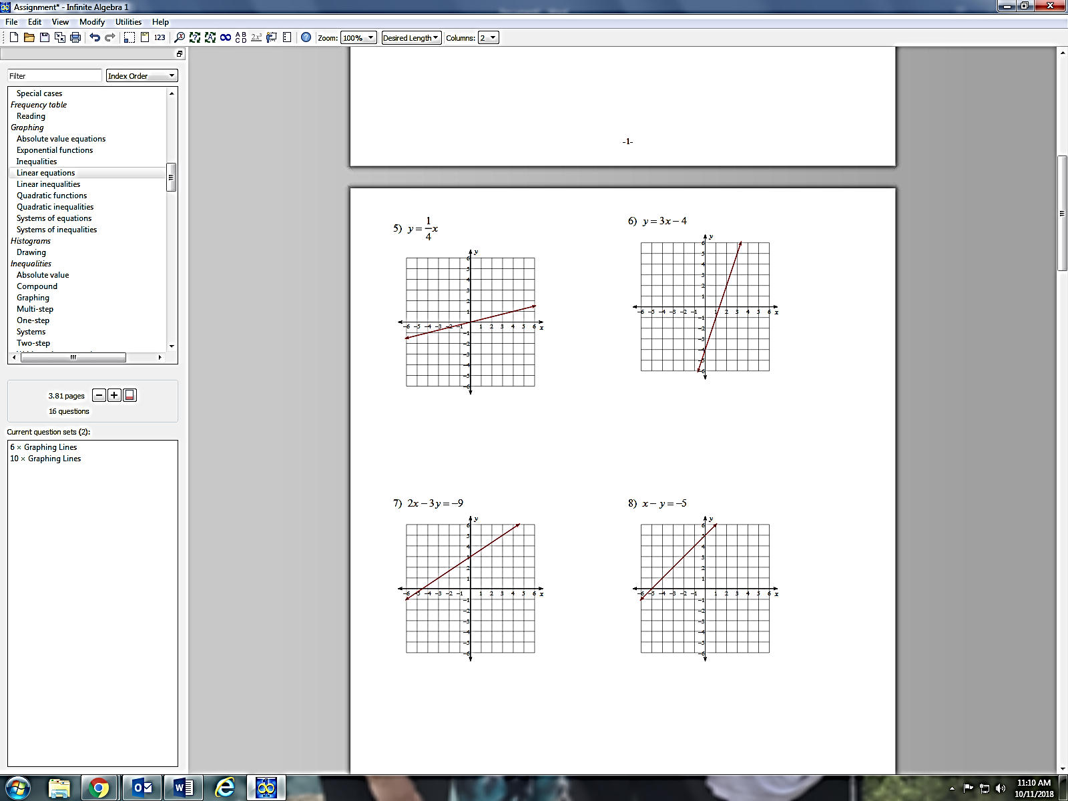**2) Write an equation for each graph in *point slope form.***

**3) Graph each equation and identify the slope**

**a.  b.  c. **

Slope:_____________________ Slope:_____________________ Slope:_____________________

**4) Write an equation in BOTH slope interceptform AND point slope form given the information:**

**a.** Passing through the points (-1,4) & (0,5) **b.** Slope = 2 and passing through the point (2,-3)

**5)** Bennett and his friends decide to go bowling. The cost for the group is $15 for shoe rentals plus $4.00 per game.

**a.** How much will it cost them to bowl 2 games?

**b**. Write an equation relating the total cost, *y,* of the outing to the number of games bowled, *x.*

**c.** How many games could the group play if they have $30.00?

**6.** You are an avid coin collector. You decide to start keeping better track of your coin collection. After 15 days you count and find that you have 155 coins. After 22 days you have a total of 218 coins.

**a.** Write an equation in POINT SLOPE form the represents this scenario (define your variables).



**b**. Convert your equation to Slope-Intercept form

**c.** How many coins did you start with?

**d.** After how many days will you have 425 coins?

e. Graph ☺