**Algebra 2:**

**5.5 Function Operations WS**

**For problems 1-2**, write the rules for the given functions, simplify as much as possible, **and** state its domain.

**1.**  and  **2.**  and 

**a.**  **a.** 

**b.**  **b.** 

**c.**  **c.** 

**d.**  **d.** 

**3.** Smapple is selling their new s-phones. The demand for the s-phone is predicted by the function. Smapple plans to charge a variable price based on the function . In both equations *x* is the cost of producing each s-phone. *Calculator allowed.*

**a.** Find and simplify an equation for Smapple’s revenue. *Hint: *

**b.** Use your equation from **part a** to find Smapple’s revenue if the cost of producing each s-phone is $100.

**For problems 4-5:** Let  and . Simplify each rule as much as possible.

**4.**  **5.** 

**a.** Domain of : **a.** Domain of :

**b.**  **b.** 

**6**. Use the graphs of  and , shown to the right, to find each value.

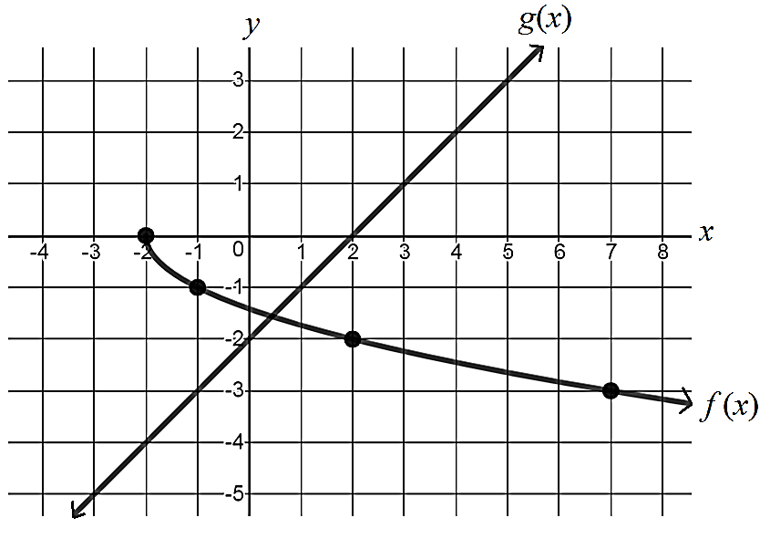**a.** 

**b.** 

**c.** 

**d.** 

**7.** Use the graph of , the table of selected values of , and the equation for  to find the indicated values.

|  |  |
| --- | --- |
|  |  |
|  | 9 |
|  | 7 |
| 0 |  |
| 3 | 5 |
| 6 |  |
| 7 | 3 |
| 8 |  |



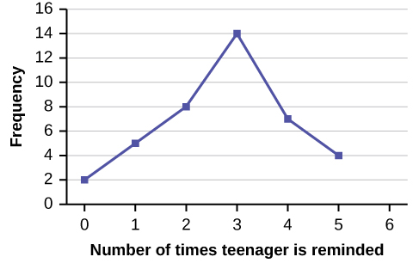**a.** 

**b.** 

**c.** 



**d.** 