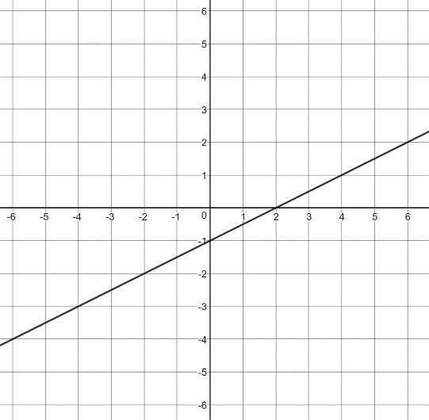**Climb the Ladder**

**1**



1. Write the equation of a line so that and passes through (-2, 1).



2. Graph on the grid provided.



3. Write the equation of a line so that and passes

through (1, -4).

4. Graph on the grid provided.

5. Check for perpendicularity by measuring angles where and intersect.

**Climb the Ladder**

**1**



1. Write the equation of a line so that and passes through (-2, 1).



2. Graph on the grid provided.



3. Write the equation of a line so that and passes

through (1, -4).

4. Graph on the grid provided.

5. Check for perpendicularity by measuring angles where and intersect.

**Climb the Ladder**

**2**



**Solve for the missing variables in each problem.**

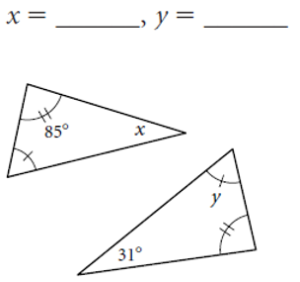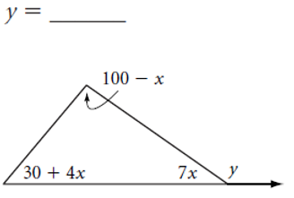1. 2.

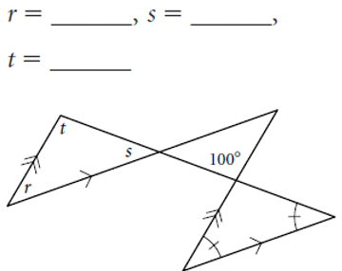3.

**Climb the Ladder**

**2**



**Solve for the missing variables in each problem.**

1. 2.

3.

**Climb the Ladder**

**3**



*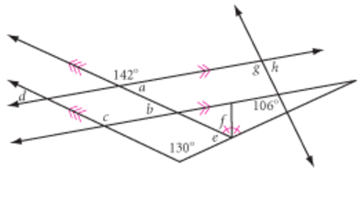Find the angle measures.*

a.

b.

c.

d.

e.

f.

g.

h.

**Climb the Ladder**

**3**



*Find the angle measures.*

a.

b.

c.

d.

e.

f.

g.

h.