Name:\_\_\_\_\_\_\_\_\_\_\_\_\_\_\_\_\_\_\_\_\_\_\_\_\_\_\_\_\_\_\_\_\_\_\_\_\_\_\_\_\_\_\_\_\_\_\_\_\_\_ Period:\_\_\_\_\_\_\_\_\_ Date: \_\_\_\_\_\_\_\_\_\_\_\_\_\_

Topic 3 Review Worksheet

For questions 1 – 4, tell whether each transformation appears to be a reflection.

1.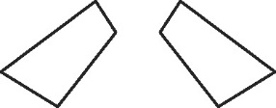 \_\_\_\_\_\_\_\_\_ 2. 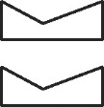 \_\_\_\_\_\_\_\_\_

3. 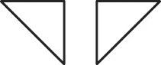 \_\_\_\_\_\_\_\_\_ 4.  \_\_\_\_\_\_\_\_\_

For questions 5 – 8, graph each image given the transformation described.

|  |  |
| --- | --- |
| 5.  if , ,  Go07an_1201praB_11[+AK]-A | 6. if , ,  Go07an_1201praB_11[+AK]-A |
| 7.  if , , ,  Go07an_1201praB_11[+AK]-A | 8.  if , , ,  Go07an_1201praB_11[+AK]-A |

**For questions 9 – 12, tell whether each transformation appears to be a translation.**

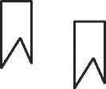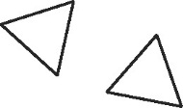 9.   \_\_\_\_\_\_\_\_\_ 10.  \_\_\_\_\_\_\_\_\_

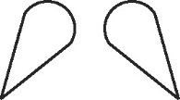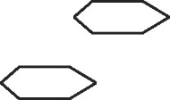 11.   \_\_\_\_\_\_\_\_\_ 12.   \_\_\_\_\_\_\_\_\_

For questions 13 – 14, graph each image given the transformation described.

|  |  |
| --- | --- |
| 13.  if , ,  Go07an_1201praB_11[+AK]-A | Go07an_1201praB_11[+AK]-A14.  if , , , |

15. A builder is trying to level out some ground with a front-end loader. He picks up some excess dirt at  and then maneuvers through the job site along the vectors , , and to get to the spot to unload the dirt.

a. At what ordered pair does the builder unload the dirt?

b. Write a composition of transformations that represents the *sequence of maneuvers* the builder takes.

c. Write a transformation to move the builder to the unloading spot in a single maneuver.

For questions 16 – 19, graph each image given the transformation described.

|  |  |
| --- | --- |
| 16.  if , ,  Go07an_1201praB_11[+AK]-A | Go07an_1201praB_11[+AK]-A17.  if , , , |
| 18.  if , ,  Go07an_1201praB_11[+AK]-A | Go07an_1201praB_11[+AK]-A19.  if , , , |

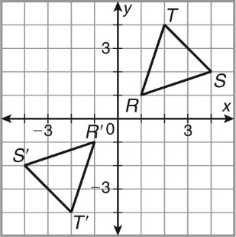

20. △RST is reflected across the y-axis, and then its image is reflected across the x-axis. Which single transformation moves the triangle from its starting position to its final position?

21. Tell whether each figure has reflectional symmetry. If so, draw all lines of symmetry.

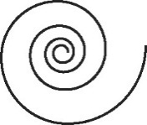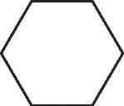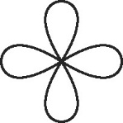 a.   b.    c.

22. Anna, Bob, and Otto write their names in capital letters. Draw all lines of symmetry for each whole name if possible.

|  |  |  |
| --- | --- | --- |
| **ANNA** | **BOB** | **OTTO** |

23. Tell whether each figure has rotational symmetry. If so, give the angle(s) of rotational symmetry.

|  |  |  |
| --- | --- | --- |
| Go07an_1205praB_08a. | Go07an_1205praB_09b. | Go07an_1205praB_10c. |

**For questions 24 – 26, use correct notation to write the composition of transformations that is shown.**

|  |  |  |
| --- | --- | --- |
| 24. | 25. | 26. |

**For questions 27 – 28, graph each composition of transformations given, , .**

|  |  |
| --- | --- |
| 27. | 28. |