Name ___________________________________________

**Algebra 2**

**5.3 Radical Parent Functions Key Features WS**

For each function, graph the parent function and state the indicated key features.

|  |  |
| --- | --- |
|  |  |
| Image result for 10x10 coordinate plane | Image result for 10x10 coordinate plane |
| Domain: | Domain: |
| Range: | Range: |
| Intervals where  is increasing: | Intervals where : |
| Average rate of change over : | Average rate of change over : |

Graph the functions below and describe the indicated features.

|  |  |
| --- | --- |
|  |  |
| Image result for 10x10 coordinate plane | Image result for 10x10 coordinate plane |
| Domain: | Domain: |
| Range: | Range: |
| Intervals where  is increasing: | Intervals where : |
| Average rate of change over : | Average rate of change over : |

|  |  |
| --- | --- |
|  |  |
| Image result for 10x10 coordinate plane | Image result for 10x10 coordinate plane |
| Domain: | Domain: |
| Range: | Range: |
| Intervals where  is increasing: | Intervals where  is increasing: |
| Average rate of change over : | Average rate of change over : |

Write the equations of the transformed functions after the following transformations.

1. Write an equation for m(x), the transformed graph of after a vertical dilation of 2 and translated left 5 and up 4.
2. Write an equation for q(x), the transformed graph of after a reflection over the x-axis and a translation right 3 and down 6.

Write the equation of the functions below.

1. 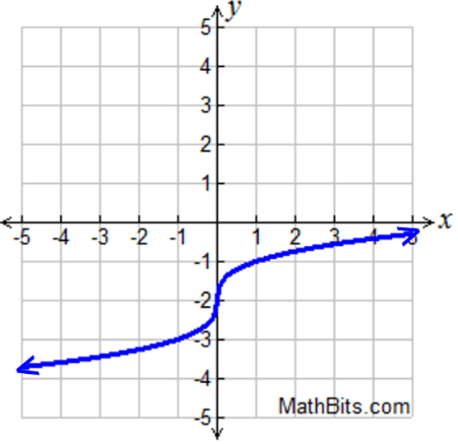 b)

