**Topic 1 Finals Review**

**Multiple Choice:** *Select the best answer.*

**1.** Which of the following equations is equivalent to 

[A]  [B]  [C]  [D] 

**2.** Solve the following equation for the unknown variable: 

[A]  [B]  [C]  [D] 

**3.** Solve the following inequality: 

[A]  [B]  [C]  [D] 

**4.** The sum of three consecutive even numbers is 54, what is the value of the second even number in the set?

[A]  [B]  [C]  [D] 

**5.** Jillian has saved $725 for her summer vacation and intends to spend $25 per week. She would like to have at least $150 remaining for the last week of summer. Which inequality represents the number of weeks, *w*, that Jillian can spend and remain within her budget?

[A]  [B]  [C]  [D] 

**6.** How many solutions will the following equation have: 

[A] One solution [B] No Solution [C] Infinitely many [D] Two solutions

**Grid-In Response:** *Grid in your answer(s) in the provided gridded response box*

**For questions 7 and 8,** Solve the following equation(s) for the unknown variable:

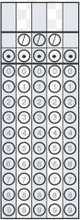

**7.  8. **

**Free Response:**

**9.** Venetta buys 2 pounds of pecans and 3 pounds of cashews. The pecans cost $4 more per pound than the cashews. She pays a total of $48. Identify how much one pound of cashews costs, and how much one pound of pecans costs.

**10.** Five friends all use $2.50 off coupons to buy themselves tickets to the movies. They spend a total of $57.50. What is the full-price cost of one movie ticket?

**11.** The equation for the volume of a right pyramid is , where *V* is the pyramid’s volume, *b* is the measure of the *base, w* is the width, and, *h* is the height.

**a.** Solve the equation for *h*

**b.** If a right pyramid has a volume of 60 cubic units, a base measure of 2 units, and a width of 6 units, what is the pyramid’s height?

**12.** Solve and graph the following inequalities

1.  **b. **



**13.** Mr. Santo Claws needs to buy special ornaments for decorating at a holiday party. He needs to buy 5 glass ornaments and 3 copper ornaments. The cost of the copper ornaments is $7 more than the glass ornaments. If he spends a total of $101, how much do the ornaments cost individually?

**Topic 2 Finals Review**

**Multiple Choice:** *Select the best answer.*

**1.** Select the linear equation that is *perpendicular* to the line  and has a y-intercept at .

[A]  [B] 

[C]  [D] 

**2.** Write the equation for a linear equation in *point slope form* with a slope of  and passes through the point.

[A]  [B]  [C]  [D] 

**3.** Calculate the slope of a line that passes through the points  and 

[A] 1/3 [B] 3 [C] -3 [D] 6

**4.** Genevieve has $90 to spend on ping pong paddles and ping-pong balls for her after-school club. Paddles cost $6 and a set of ping pong balls cost $5. Write an equation in standard form to model this scenario. Let *x* represent the number of paddles and *y* represent the number of balls.

[A]  [B]  [C]  [D] 

**5.** Write a linear equation in *slope intercept form* that passes through the points  and 

[A]  [B]  [C]  [D] 

**6.** Select the 2 equations that are represented in the graph below.

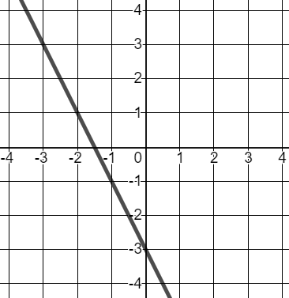

[A]  [B] 

[C]  [D] 

**Free Response:**

**7.** Write the equation of a line that passes through the point  and is *perpendicular* to the line

 in point slope form.

**8.** Biologists have discovered that the number of chirps some crickets make per minute is related to the temperature outside. The relationship is linear. When crickets chirp 124 times, it is about F. When they chirp 172 times per minute, it is about F.

**a.** Define your variables. **b.** Identify the two given coordinate points.

**c.** Calculate the average rate of change (slope). Interpret the meaning in the context of the problem.

**d.** Write the linear equation in point-slope form.

**9.** Graph each equation.

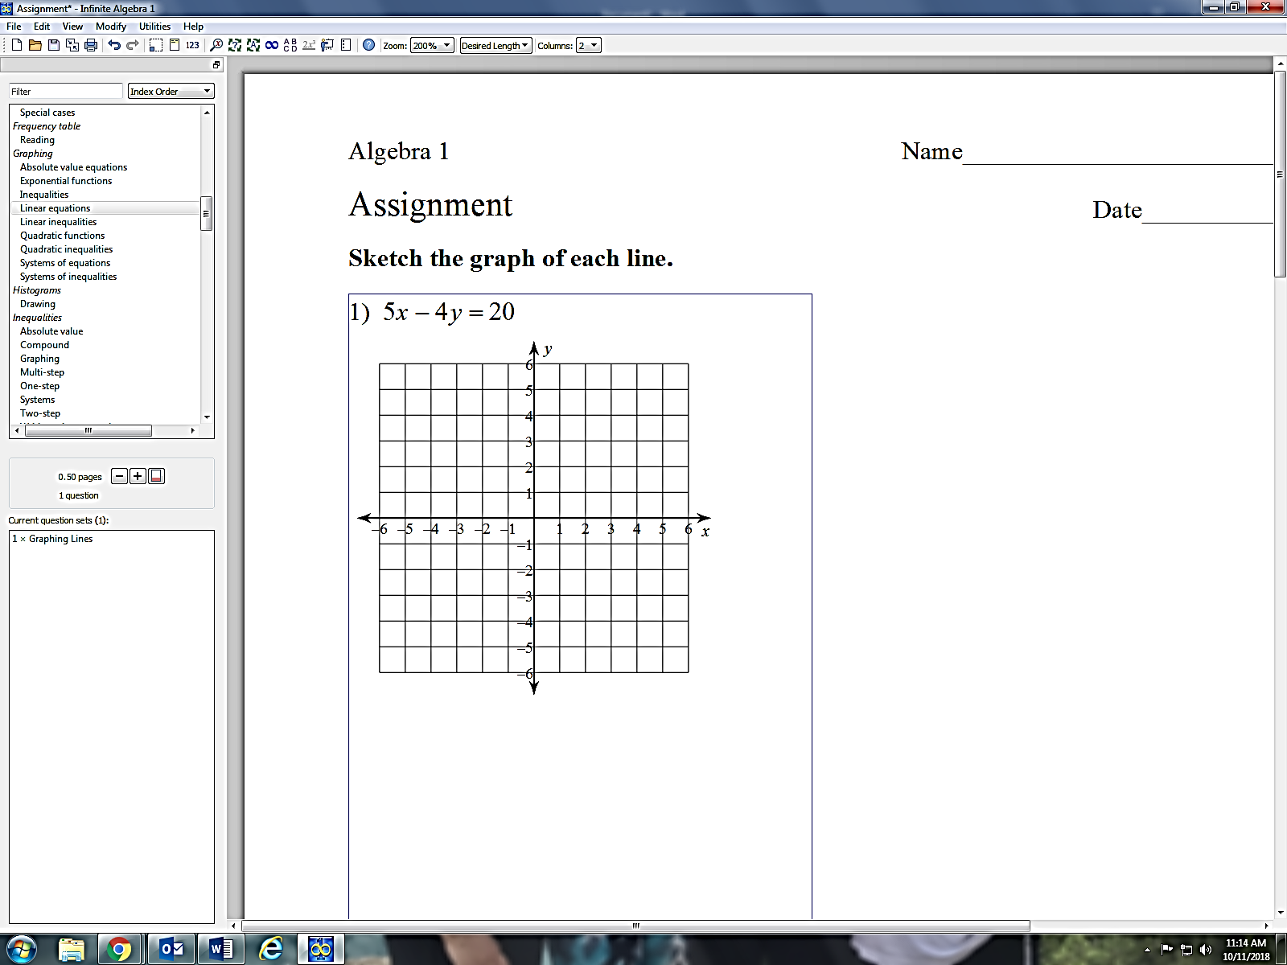**a.  b.  c. **

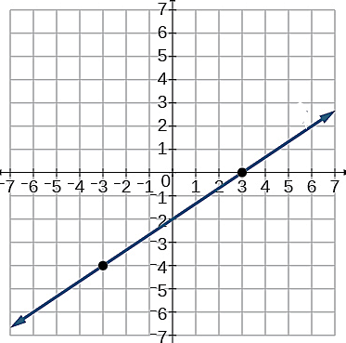**10.** Use the graph below to answer the following questions.

**a.** What is the slope of the line?

**b.** What is the y intercept?

**c.** What is the x-intercept?

**d.** Write the equation in point slope form.

**e.** Write an equation that is parallel to this line that passes through the point .

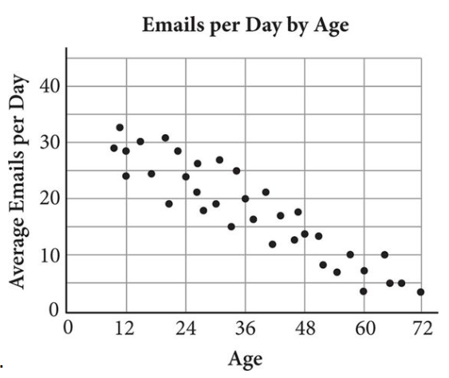**Topic 3 Finals Review**

**Multiple Choice:** *Select the best answer.*

**1.** Which of the following equations best represents the line of best fit of the date shown in the figure.

[A]  [B] 

[C]  [D] 

**2.** Which recursive rule best describes the sequence -5, -3, -1, 1, …

[A]  [B]  [C]  [D] 

**3.** Which recursive rule best describes the sequence 3, 14, 25, 36, …

[A]  [B]  [C]  [D] 

**4.** Which explicit rule best describes the sequence 7, 23, 39, 55, …

[A]  [B]  [C]  [D] 

**5.**  Which *r-*value suggests a strong positive correlation?

[A] *r* = 0.17454 [B] *r* = −0.17454 [C] *r* = 0.9964 [D] *r* = −0.9626

**6.** Which of the following sequences are arithmetic? **Select ALL that apply**

[A] −30, −40, −50, −60, … [B] 35, 32, 29, 26, … [C] −3, −23, −43, −63, … [D] 7, 14, 28, 56, …

**Free Response:**

**7.** For each graph, state whether it is a function and discrete or continuous then state the domain and range of each on the next page.

Discrete or Continuous Discrete or Continuous Discrete or Continuous

a. Function? ________ b. Function?______ c. Function?______

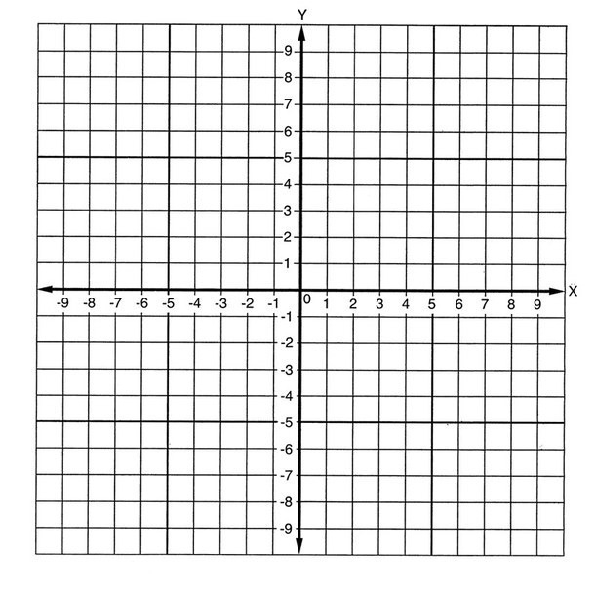



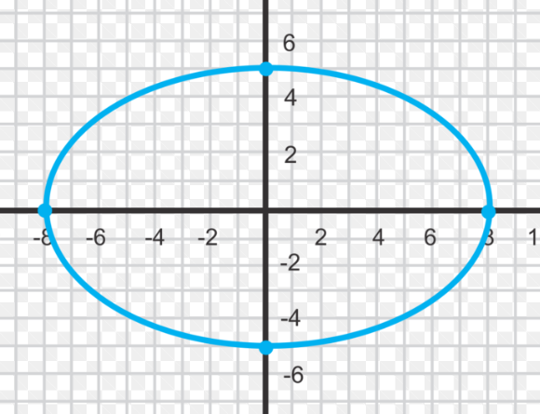

Domain: Domain: Domain:

Range: Range: Range:

**8.** Given, , and the *graph* of evaluate each of the following.

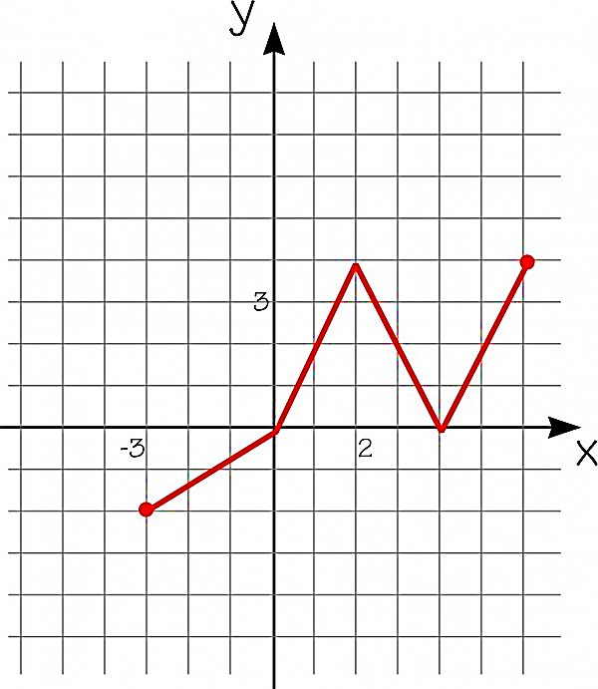a.  b. 

c. *x* , when *h(x)=4* d. 

e., when 

**9.** State whether each is a function and then state the domain and range.

|  |  |
| --- | --- |
| X | Y |
| 1 | 3 |
| 3 | 4 |
| -3 | 8 |
| 4 | 6 |
| 7 | 8 |

a. Function? b. (1,3),(2,6),(0,6),(1,4) Function?

Domain: Domain:

Range: Range:

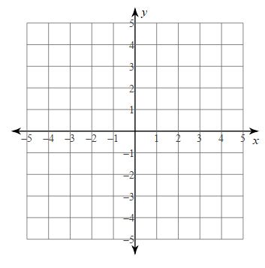**Topic 4 Finals Review**

**Multiple Choice:** *Select the best answer.*

1. Solve the systems of equations by graphing. 



[A]  [B] 

[C]  [D] No Solution

1. Solve the system of equations by substitution. 



[A]  [B]  [C]  [D] 

1. Solve the system of equations by substitution. 



[A]  [B]  [C]  [D] 

1. Solve the system of equations by elimination. 



[A]  [B]  [C]  [D] 

1. Solve the system of equations by elimination. 



[A]  [B]  [C]  [D] 

1. Sarah has $25 dollars and earns $10 per week from tutoring. She wants to have at least $120 by the end of the summer. Write a linear inequality that represents this scenario, where *x* represents the number of weeks Caroline works.

**[A]**  **[B]** **[C]**  **[D]** 

1. You need at least 3 pounds of fruit to make muffins. Blueberries cost $4 per pound, strawberries cost $3 per pound, and you can spend at most $21 on fruit. Write a system of inequalities for this scenario, where x is blueberries and y is strawberries.

[A]  [B]  [C]  [D] 

   

**Free Response:**

**8.** Solve the systems of equations by graphing.

 

**9.** Solve the system of equations by any method.





**10.** Solve the system of equations by any method.





**11.** The senior classes at Issaquah and Skyline planned separate trips to Portland. The senior class at Issaquah rented 1 van and 6 buses with 372 students. Skyline rented 4 vans and 12 buses with 780 students. Each van and each bus carried the same number of students. Write and solve a system of equations to determine how many students can fit in a van and how many students can fit in a bus.

**12.** Which of these points are in the solution set of the system of inequalities? (**Select all that apply.)**



 

[A] (2, 1) [B] (-2, 0)

[C] (0, -2) [D] (2, -3)

[E] (4, 4) [F] (4, 0)

**Topic 6 Finals Review**

**Multiple Choice:** *Select the best answer.*

**1.** Simplify: 

[A]  [B]  [C]  [D] 

**2.** Simplify: 

[A]  [B]  [C]  [D] None of the above

**3.** Simplify: 

[A]  [B]  [C]  [D] 

**4.** Simplify: 

[A]  [B]  [C]  [D] 

**5.** Simplify:

[A]  [B] [C]  [D] 

**6.** Given the function, , identify the growth/decay rate.

[A] [B]  [C]  [D] 

**7.** Under perfect conditions a certain bacteria increases by 10% every day. When first measured a petri dish has 1000 bacteria. Which function represents the amount of bacteria after x days?

[A]  [B]  [C]  [D] 

**8.** Find the common ratio for the geometric sequence 2, 8, 32, 128, …

[A]  [B]  [C]  [D] 

**9.** Which exponential function represents the table of values?

|  |  |  |  |  |
| --- | --- | --- | --- | --- |
| x | 0 | 1 | 2 | 3 |
| f(x) | 3 | 15 | 75 | 375 |

[A]  [B] 

[C]  [D] 

**Free Response:**

**10.** Write an exponential function to represent the function graphed below.

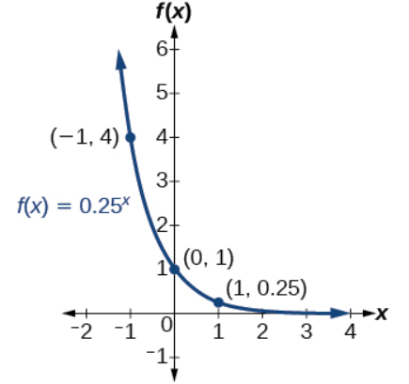

**11.** Graph the exponential functions.

1.  b) 

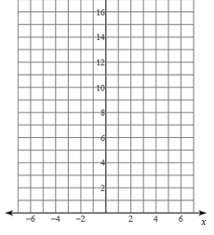 

**12.** Tell whether each equation is true or false. If it is false, change the right side to make the equation true.

1. (2x3)3 = 6x6 b) 2(3x3)-1 = -6x-2

**13.** You invest $25,000 in an account that gets 12% annual interest.

1. Write an exponential function to represent the balance in the account after x years.
2. How much would you have in 10 years?